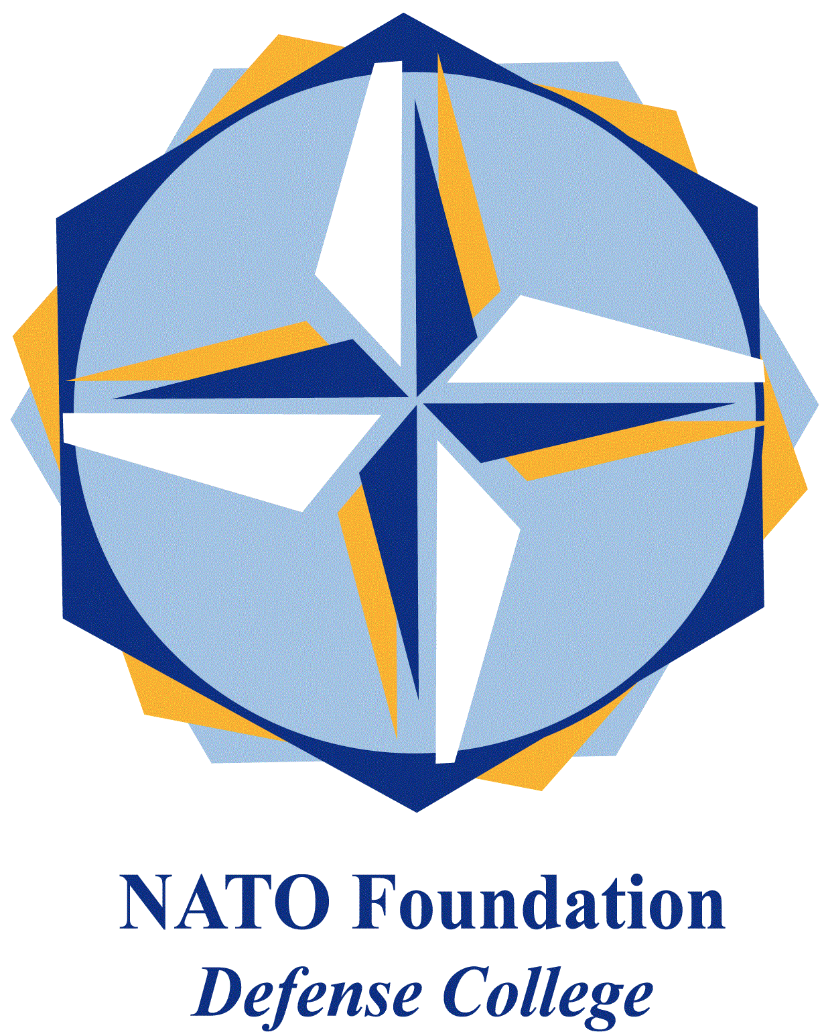
NATO DEFENSE COLLEGE FOUNDATION
STRATEGIC TRENDS
April 2015

How the West has pushed Russia in the arms of China
The year-old US-led economic sanctions against Russia for backing separatists in eastern Ukraine and the decision by all major western leaders not to attend the big celebrations in Moscow of the 70th Anniversary of the Allied victory in the Second World War, are driving Russia and China closer together.
There are ample reasons to believe that sanctions, rather than forcing Russia to review its position on the Ukrainian crisis, have pushed it in the arms of China which is the only major economy outside the sanctions regime and is using its neutrality to attract Russia into its economic and political sphere.
The fact that the Chinese President Xi Jinping has been declared “guest of honour” of the celebrations is a clear indication of Russia’s strategy to counter the boycott by the Western Alliance. President Xi and President Putin describe themselves as "good friends" and met several times since the Ukrainian crisis began.
All efforts by the EU and its member states to persuade China to put pressure on Moscow have been of no avail. China stuck to its principle of non-interference and refused to get involved. Discussions were held between the EU and China during Xi Jinping’s visit to Brussels in March last year and again at the ASEM meeting in October but, despite China’s sensitivity to sovereignty issues, it remained neutral.
Chinese media even condemned “Western interference” in Ukraine and expressed sympathy for Moscow. The Chinese authorities did say they were “shocked” after pro-Russian separatists shot down a Malaysian airliner, but still did not utter any criticism against Russia. China abstained in the subsequent UN Security Council vote on a resolution condemning the referendum in Crimea, but it went short to be either a condemnation of Russia’s actions or a show of support to the sanctions..
Both the EU and the US seem to have reached a stalemate in their dealings with Russia and, what is worst, at this point can do very little if anything to reverse the situation. Even if NATO would renege on its intention to eventually admit Georgia and Ukraine, it would still not change the dynamics of the Russian-Chinese partnership. Moscow and Beijing are now set to develop strong economic and political ties for the foreseeable future.
In the United States, Obama has entered the last leg of his term in office and is unlikely to reappraise his approach to the Ukrainian crisis. A change of mind would prompt outrage in Congress and the media, eclipsing Obama’s other foreign policy initiatives. A reconciliation with the Kremlin, if possible, would have to wait until a new president with a new mandate will take office which will happen in 2017 giving plenty of time to China to make deep inroads into the Russian economy.
Moreover, unlike the leaders of the Western democracies. Putin and Xi exercise complete control of their respective political systems and are both likely to remain in power for a long period - Xi until 2022 and Putin until 2024. Such span of time into the future gives them a strong incentive to continue cooperating with each other.
As far as Europe is concerned, its political fragmentation into 28 separate national governments deprives it of any possibility to exert a strong influence in, let alone shape the world reality. Paradoxically enough, the imposition of sanctions against Russia has been a rare case of Europe adopting a united stance. Unfortunately though, it seems to have worked against Europe’s own interests.

